**Case Study – Textile Sales**

CREATE DATABASE TEXTILE;

USE TEXTILE;

CREATE TABLE sales(

prod_id VARCHAR(6) NOT NULL

,qty INTEGER NOT NULL

,price INTEGER NOT NULL

,discount INTEGER NOT NULL

,member VARCHAR(5) NOT NULL

,txn_id VARCHAR(6) NOT NULL

,start_txn_time VARCHAR(24) NOT NULL);

CREATE TABLE product_prices(

id INTEGER NOT NULL PRIMARY KEY

,product_id VARCHAR(6) NOT NULL

,price INTEGER NOT NULL);

INSERT INTO product_prices(id,product_id,price) VALUES (7,'c4a632',13);

INSERT INTO product_prices(id,product_id,price) VALUES (8,'e83aa3',32);

INSERT INTO product_prices(id,product_id,price) VALUES (9,'e31d39',10);

INSERT INTO product_prices(id,product_id,price) VALUES (10,'d5e9a6',23);

INSERT INTO product_prices(id,product_id,price) VALUES (11,'72f5d4',19);

INSERT INTO product_prices(id,product_id,price) VALUES (12,'9ec847',54);

INSERT INTO product_prices(id,product_id,price) VALUES (13,'5d267b',40);

INSERT INTO product_prices(id,product_id,price) VALUES (14,'c8d436',10);

INSERT INTO product_prices(id,product_id,price) VALUES (15,'2a2353',57);

INSERT INTO product_prices(id,product_id,price) VALUES (16,'f084eb',36);

INSERT INTO product_prices(id,product_id,price) VALUES (17,'b9a74d',17);

INSERT INTO product_prices(id,product_id,price) VALUES (18,'2feb6b',29);

CREATE TABLE product_hierarchy(

id INTEGER NOT NULL PRIMARY KEY

,parent_id INTEGER

,level_text VARCHAR(19) NOT NULL

,level_name VARCHAR(8) NOT NULL

);

INSERT INTO product_hierarchy(id,parent_id,level_text,level_name) VALUES (1,NULL,'Womens','Category');

INSERT INTO product_hierarchy(id,parent_id,level_text,level_name) VALUES (2,NULL,'Mens','Category');

INSERT INTO product_hierarchy(id,parent_id,level_text,level_name) VALUES (3,1,'Jeans','Segment');

INSERT INTO product_hierarchy(id,parent_id,level_text,level_name) VALUES (4,1,'Jacket','Segment');

INSERT INTO product_hierarchy(id,parent_id,level_text,level_name) VALUES (5,2,'Shirt','Segment');

INSERT INTO product_hierarchy(id,parent_id,level_text,level_name) VALUES (6,2,'Socks','Segment');

INSERT INTO product_hierarchy(id,parent_id,level_text,level_name) VALUES (7,3,'Navy Oversized','Style');

INSERT INTO product_hierarchy(id,parent_id,level_text,level_name) VALUES (8,3,'Black Straight','Style');

INSERT INTO product_hierarchy(id,parent_id,level_text,level_name) VALUES (9,3,'Cream Relaxed','Style');

INSERT INTO product_hierarchy(id,parent_id,level_text,level_name) VALUES (10,4,'Khaki Suit','Style');

INSERT INTO product_hierarchy(id,parent_id,level_text,level_name) VALUES (11,4,'Indigo Rain','Style');

INSERT INTO product_hierarchy(id,parent_id,level_text,level_name) VALUES (12,4,'Grey Fashion','Style');

INSERT INTO product_hierarchy(id,parent_id,level_text,level_name) VALUES (13,5,'White Tee','Style');

INSERT INTO product_hierarchy(id,parent_id,level_text,level_name) VALUES (14,5,'Teal Button Up','Style');

INSERT INTO product_hierarchy(id,parent_id,level_text,level_name) VALUES (15,5,'Blue Polo','Style');

INSERT INTO product_hierarchy(id,parent_id,level_text,level_name) VALUES (16,6,'Navy Solid','Style');

INSERT INTO product_hierarchy(id,parent_id,level_text,level_name) VALUES (17,6,'White Striped','Style');

INSERT INTO product_hierarchy(id,parent_id,level_text,level_name) VALUES (18,6,'Pink Fluro Polkadot','Style');

CREATE TABLE product_details(

product_id VARCHAR(6) NOT NULL PRIMARY KEY

,price INTEGER NOT NULL

,product_name VARCHAR(32) NOT NULL

,category_id INTEGER NOT NULL

,segment_id INTEGER NOT NULL

,style_id INTEGER NOT NULL

,category_name VARCHAR(6) NOT NULL

,segment_name VARCHAR(6) NOT NULL

,style_name VARCHAR(19) NOT NULL);

INSERT INTO product_details(product_id,price,product_name,category_id,segment_id,style_id,category_name,segment_name,style_name) VALUES ('c4a632',13,'Navy Oversized Jeans - Womens',1,3,7,'Womens','Jeans','Navy Oversized');

INSERT INTO product_details(product_id,price,product_name,category_id,segment_id,style_id,category_name,segment_name,style_name) VALUES ('e83aa3',32,'Black Straight Jeans - Womens',1,3,8,'Womens','Jeans','Black Straight');

INSERT INTO product_details(product_id,price,product_name,category_id,segment_id,style_id,category_name,segment_name,style_name) VALUES ('e31d39',10,'Cream Relaxed Jeans - Womens',1,3,9,'Womens','Jeans','Cream Relaxed');

INSERT INTO product_details(product_id,price,product_name,category_id,segment_id,style_id,category_name,segment_name,style_name) VALUES ('d5e9a6',23,'Khaki Suit Jacket - Womens',1,4,10,'Womens','Jacket','Khaki Suit');

INSERT INTO product_details(product_id,price,product_name,category_id,segment_id,style_id,category_name,segment_name,style_name) VALUES ('72f5d4',19,'Indigo Rain Jacket - Womens',1,4,11,'Womens','Jacket','Indigo Rain');

INSERT INTO product_details(product_id,price,product_name,category_id,segment_id,style_id,category_name,segment_name,style_name) VALUES ('9ec847',54,'Grey Fashion Jacket - Womens',1,4,12,'Womens','Jacket','Grey Fashion');

INSERT INTO product_details(product_id,price,product_name,category_id,segment_id,style_id,category_name,segment_name,style_name) VALUES ('5d267b',40,'White Tee Shirt - Mens',2,5,13,'Mens','Shirt','White Tee');

INSERT INTO product_details(product_id,price,product_name,category_id,segment_id,style_id,category_name,segment_name,style_name) VALUES ('c8d436',10,'Teal Button Up Shirt - Mens',2,5,14,'Mens','Shirt','Teal Button Up');

INSERT INTO product_details(product_id,price,product_name,category_id,segment_id,style_id,category_name,segment_name,style_name) VALUES ('2a2353',57,'Blue Polo Shirt - Mens',2,5,15,'Mens','Shirt','Blue Polo');

INSERT INTO product_details(product_id,price,product_name,category_id,segment_id,style_id,category_name,segment_name,style_name) VALUES ('f084eb',36,'Navy Solid Socks - Mens',2,6,16,'Mens','Socks','Navy Solid');

INSERT INTO product_details(product_id,price,product_name,category_id,segment_id,style_id,category_name,segment_name,style_name) VALUES ('b9a74d',17,'White Striped Socks - Mens',2,6,17,'Mens','Socks','White Striped');

INSERT INTO product_details(product_id,price,product_name,category_id,segment_id,style_id,category_name,segment_name,style_name) VALUES ('2feb6b',29,'Pink Fluro Polkadot Socks - Mens',2,6,18,'Mens','Socks','Pink Fluro Polkadot');

1. **What was the total quantity sold for all products?**

SELECT SUM(qty) AS total_quantity_sold

FROM sales;

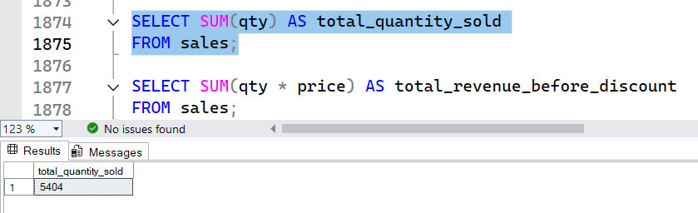

1. **What is the total generated revenue for all products before**

**discounts?**

SELECT SUM(qty * price) AS total_revenue_before_discount

FROM sales;

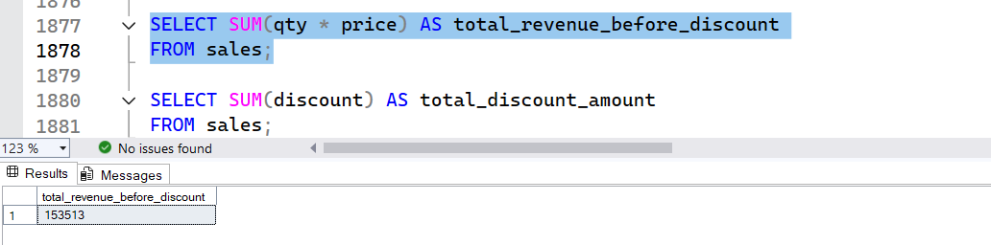

1. **What was the total discount amount for all products?**

SELECT SUM(discount) AS total_discount_amount

FROM sales;

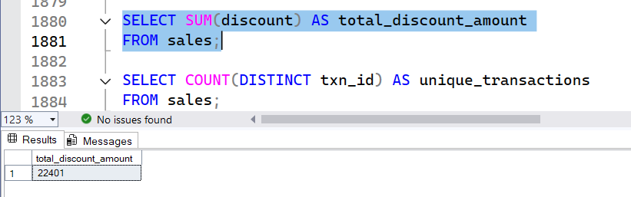

1. **How many unique transactions were there?**

SELECT COUNT(DISTINCT txn_id) AS unique_transactions

FROM sales;

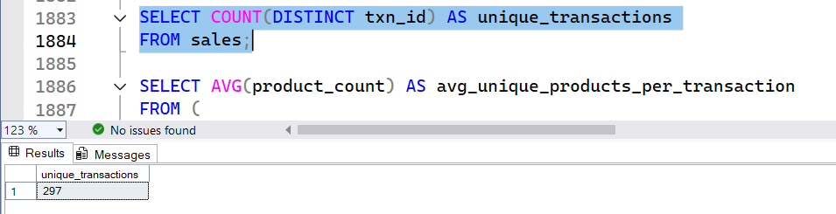

1. **What are the average unique products purchased in each**

**transaction?**

SELECT AVG(product_count) AS avg_unique_products_per_transaction

FROM (

SELECT txn_id, COUNT(DISTINCT prod_id) AS product_count

FROM sales

GROUP BY txn_id)

txn_products;

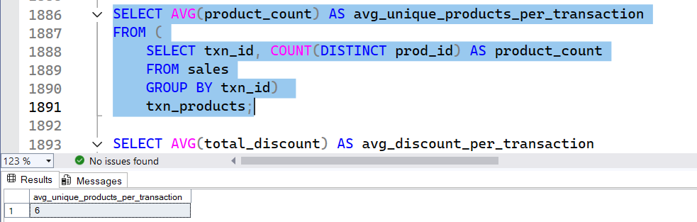

1. **What is the average discount value per transaction?**

SELECT AVG(total_discount) AS avg_discount_per_transaction

FROM (

SELECT txn_id, SUM(discount) AS total_discount

FROM sales

GROUP BY txn_id

) txn_discounts;

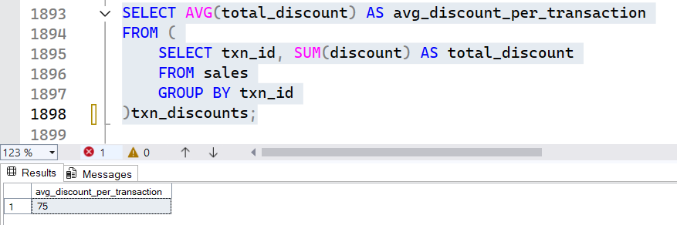

**Submitted by**

Siva Balan T